

Speakers Bureau

Program Guide 2008-2009

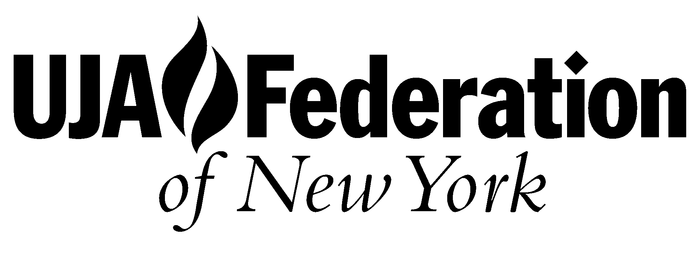

Jewish Board of Family
and Children's Services

120 West 57th Street, Tel: 212-397-4197 New York, NY 10019 Fax: 212-399-3525
jacs@jacsweb.org www.jacsweb.org
Jewish Alcoholics,
Chemically Dependent Persons
And Significant Others
 ®

Dear Rabbis, Educators and Jewish Communal Professionals

Enclosed is the new program guide for the academic year 2008-2009. This is a short guide to show the various Education and Prevention programs that JACS provides.

JACS is pleased to announce that we have added an exciting new program to our current curriculum. Over the summer JACS became partners with BeitT’Shuvah rehab to exclusively bring the Partner’s in Prevention Program to the East Coast. This program teaches Judaism as a path to promote self-acceptance, self-worth, spiritual values and family harmony. It focuses on the emotional and spiritual issues that underlie addictive and self-destructive behaviors while teaching Jewish spiritual tools to help change those behaviors, to reduce stress, improve self-image and strengthen family relationships.

All our programs are run by trained staff, recovering JACS members, clinical and rabbinic leaders who work together in co-leading workshops for each group. Depending on the size of audience there are several leaders who moderate multiple / simultaneous groups to create a more effective learning environment. The JACS delivery process is a flexible program that accommodates the needs of each group we work with. Our ultimate goal is to establish a customized program includes timing, budget and other resources.

If you have any questions or would like to book a program please call the JACS office 212-397-4197 or by email sdarack@jbfcs.org

Sincerely,

Sharon Darack
JACS Program Director

Education Program Structure for Students

- Introduction to JACS, substance abuse and speakers.

- Watch DVD on the effects of substance abuse. Dieing High in the ER

- The effects of the DVD

- Split into smaller groups of about 25-30 students. Each group will have one or two speakers that will share their stories of substance abuse. Followed by Q & A and discussions on addiction. The groups will be led by a JACS group leader.

- At the end of the breakout groups an Education and Prevention Pack will be handed out to all students.

- Once the program has come to an end the appointed staff from the school and JACS group leaders meets for feedback and evaluation.

Teachers and advisors are invited to join in for the first part of the program. Small group sessions are only for students, which are led by trained JACS leaders and volunteers. This allows the students to feel safe and comfortable to ask questions and share information in a confidential and non judgmental environment. The students are informed at the start of the groups that if we feel they are at risk we will have to inform someone in their school.

A Joint Program between JACS and Beit T’Shuvah Rehab
Partners in Prevention

Partners in Prevention is a program focusing on Judaism as a path to promote self-acceptance, self-worth, spiritual values and family harmony. It addresses the emotional and spiritual issues underlying addictive and self-destructive behaviors, teaching Jewish spiritual tools to change behavior, to reduce stress, improve self-image and strengthen family relationships.

Each session is approximately 50- 70 minutes long. Each session utilizes an Interactive Journaling workbook complete with helpful graphics, color on every page, user friendly layout and an experiential learning process. The curriculum is comprised of 6 modules for youth and 1 module for parent workshops. Each module takes about three hours, which can be covered in one, two or three sessions. This program is suitable for students in 6th-12th Grades.

Module 1
- Who Am I Today? – This module introduces the journey to adulthood and the question, “Why be Jewish?” Through guided journaling and group discussion, participants explore the balance between their inherent uniqueness and their membership in a community. Myths and cultural stereotypes are explored and participants are given the opportunity to identify the role Jewish teachings and culture play in their lives.

Module 2
- My Core Values – This important segment of the journey gives young people an opportunity to explore ways to make healthy decisions based on core Jewish values. The concepts of wholeness, Kedoshim and both/and are explored.

Module 3
- Personal Inventory – This module helps young people look at the personal qualities that either support or harm their efforts to make positive choices on their journey to adulthood. Upon completing their inventory and identifying those areas where they have “missed the mark,” participants will be introduced to the process of T’shuvah, the “return home.”

Module 4

- My Relationships- This Journal provides youth the opportunity to explore the importance of the loving, healthy relationships that will sustain them on their journey to adulthood. The difference between relationships based on contract versus covenant is defined. The obligations between parent and child and the covenantal relationships with God and community are explored

Module 5
- Alcohol and Drug Education – This segment prepares Jewish youth for making informed decisions about drugs and alcohol. Participants will learn to apply to their own lives what the Jewish tradition, faith and laws say about destructive behaviors. Youth will learn to build the skills that will help them resist pressures and temptations to experiment with drugs and alcohol.

Module 6
- My Future, My Faith – This Journal gives young people the opportunity to explore their unique liberation from various kinds of bondage by applying the principles of the Pesach holiday to their daily lives. A “faith compass” will guide their choices and help them prepare for the road that lies ahead. Goal setting, values identification and planning are key components of this module.

Partnership with Parents

Parents are a vital part of the Journey. The Parent Sessions will include:
Supporting My Child- This segment provides parents and caregivers –the opportunity to actively participate in the Partners in Prevention learning experience. Participants will learn how their attitudes and behaviors impact their child’s risk of using drugs and alcohol. Journaling exercises parallel many of the youth exercises and are presented from the adult perspective. The family covenant and the parent/caregiver roles will be explored.

Education Program Structure for Parents & Guardians

- Intro to the program and JACS.

- Watch DVD on the effects of substance abuse. Dieing High in the ER

- Talk about the DVD and the effects of it

- Addiction Professional: Addiction among adolescents, what are the signs for using and abusing and how can we help teens in the community.

- Two Speakers:
Parent Speaker: sharing their story of their family’s struggles with addiction.

Teen Speaker: sharing their experiences of addiction, recovery and the effect it had on their family.

- Questions and Answers.

- Information packs.

Education Program Structure for Rabbi, Staff and Faculty Members

- Intro to the program and JACS

- Addiction Professional looking at:

  - Addiction among adolescents.
  - What are the signs of using and abusing?
  - Realistic and effective policies for schools.
  - Stages or recovery and support groups.

- Teen Speaker - sharing their experiences of addiction, recovery, the effects of it had on their family and school.

- How can Teachers most effectively communicate with their students who are at risk?

- Questions and Answers.

- Information packs.

Symposium: JACS Book

“Jewish Sister’s in Sobriety”

- Welcoming and Introduction by Moderator.

- Moderator will announce that questions should be written on cards provided and put in a basket that will be passed around after the last speaker. (index cards and pencils should be handed to all attendees upon arrival)

- Watch DVD on addiction

- Introduction of the Speaker 1

- Speaker 1

- Introduction of Speaker 2

- Speaker 2

- Introduction of the Speaker 3

- Speaker 3

- After the 3rd speaker finishes the moderator will ask for a basket to be passed around to allow the audience to put in their questions

- Q and A facilitated by Moderator.

- Closing presentation

Education Program Structure for Adults

- Introduction to the program and JACS.

- Watch DVD on the effects of substance abuse. Dieing High in the ER

- Talk about the DVD and the effects of it

- Addiction Professional: Addiction among adolescents, what are the signs for using and abusing and how can we help teens in the community.

- Speakers:
- (Select two speakers that you would like part of the program)

- Teen/Young Adult Speaker: sharing their experiences of addiction, recovery and the effect it had on their family.

- Adult Speaker: Sharing the story of addiction and recovery.

- Family Member: sharing the story of their struggles with a child, spouse, sibling, parent, friend or significant other that are addicts and the effects it had on their family.

- Questions and Answers.

- Resources and hand out JACS pack

Topics used in small discussion groups with teens

- What is the biggest problem for teens here – drugs, alcohol, inhalants, food, gambling, cigarettes, or…?

- Do you know anyone who is in trouble with drugs, alcohol, food, gambling?

- How has it affected his/her life? How has it affected the family and those around them?

- Do you think it is possible to help someone abusing substances? Have you tried?

- Knowing the potential risks to life and health, why do people/ teenagers use drugs?

- Will going to college change the way you currently think about drug and alcohol use?

- When does abuse/ experimentation become an addiction?

Self-diagnosed disease, measured by damage to self and others, cannot stop using, and focus on supply to neglect of normal activities.

- Do you think alcohol or drug use can affect your religious beliefs or observances – or vice versa?
Do religious observances promote drinking (Purim, Simchas Torah)?

- How do you deal with peer pressure – is there peer pressure?

- Is Marijuana addictive? Yes! Users cannot control use, focus on supply.

- Does the partying – drinking – drugging of parents influence teens? How?

- Drugs & alcohol promote careless behavior – sex with someone you would not ordinarily choose, unprotected sex, getting in a car with a drunk driver, going places you would not normally go.

To book a JACS program or to find out further information contact
Sharon Darack, JACS Program Director
212-397-4197 ext.226
e-mail sdarack@jbfcs.org
www.jacsweb.org

